
Cloud Computing Lab

Submitted to:
Engr. Muhammad Shoaib

Submitted by:
Hania Akbar

Reg no:
2023-BSE-026

Section:
A

Lab 8 – AWS: Account Setup, IAM, VPC Inventory, EC2, Docker & Gitea

Task 1 — Create an AWS account and enable UAE (me-central-1)

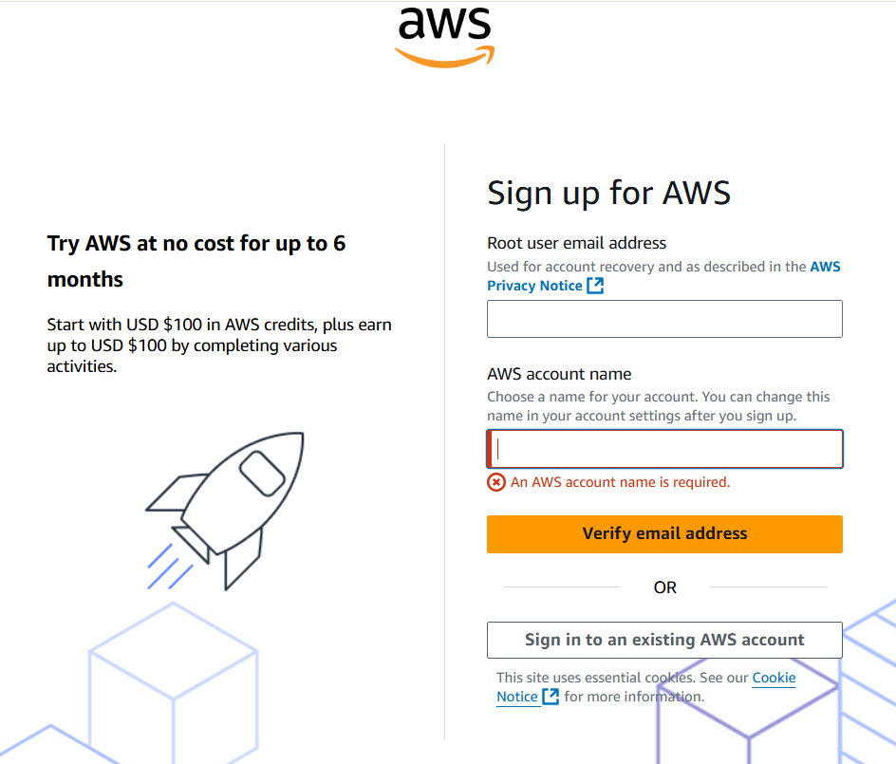

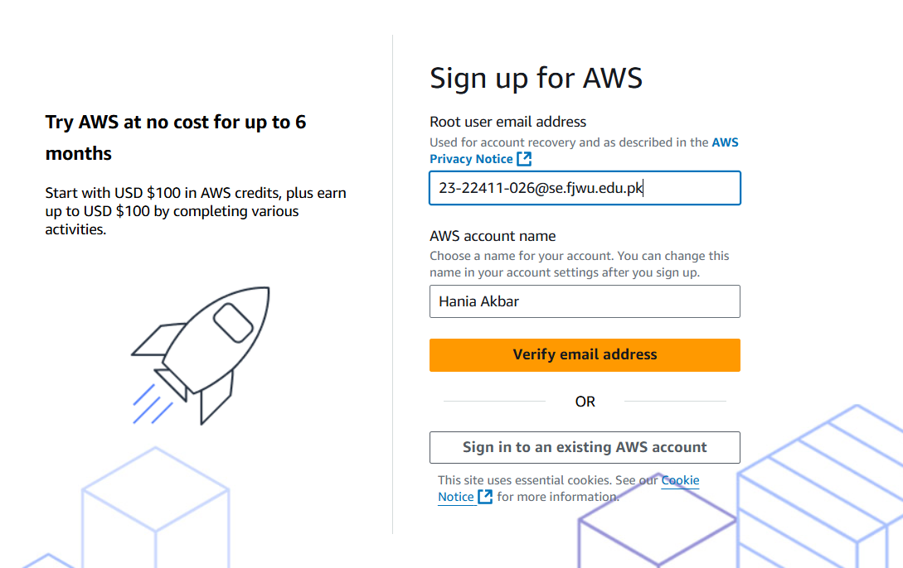

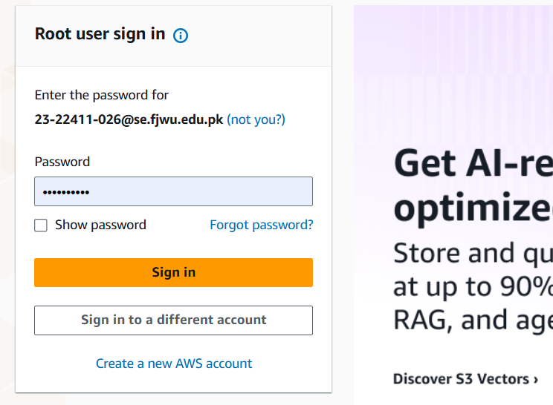

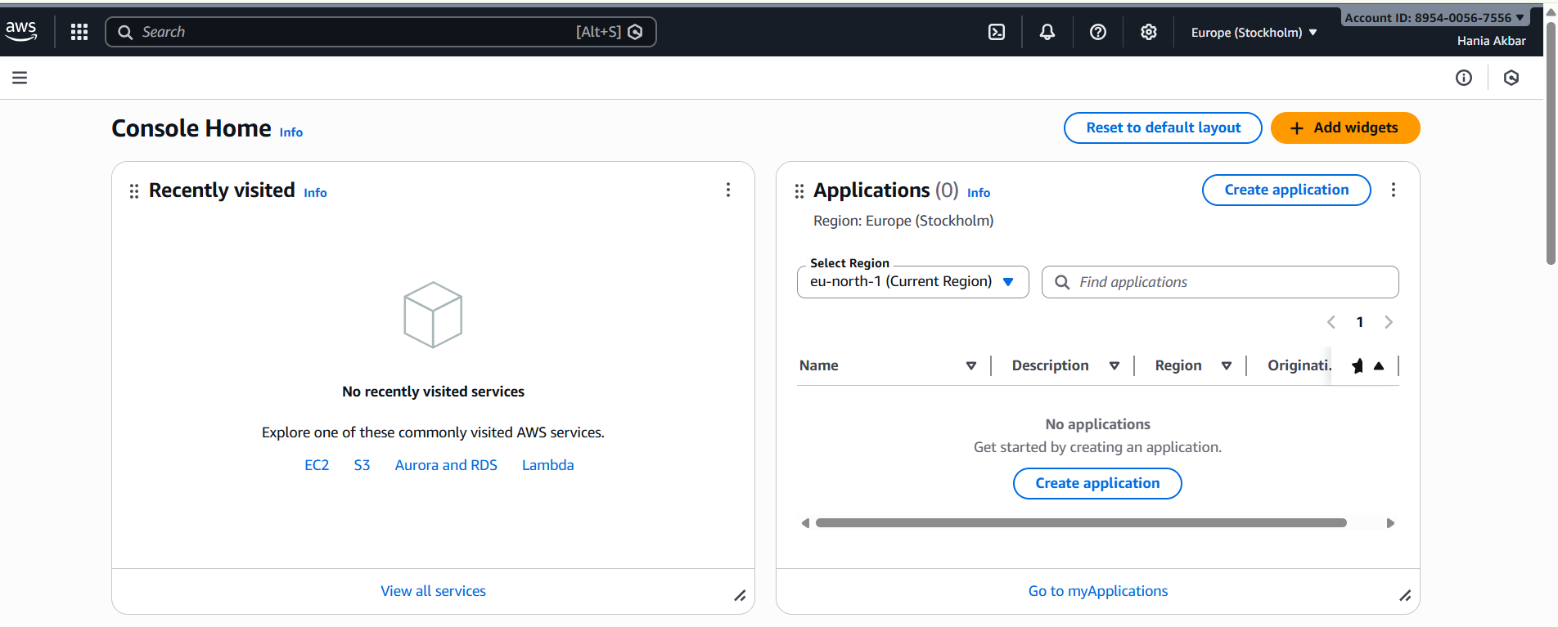

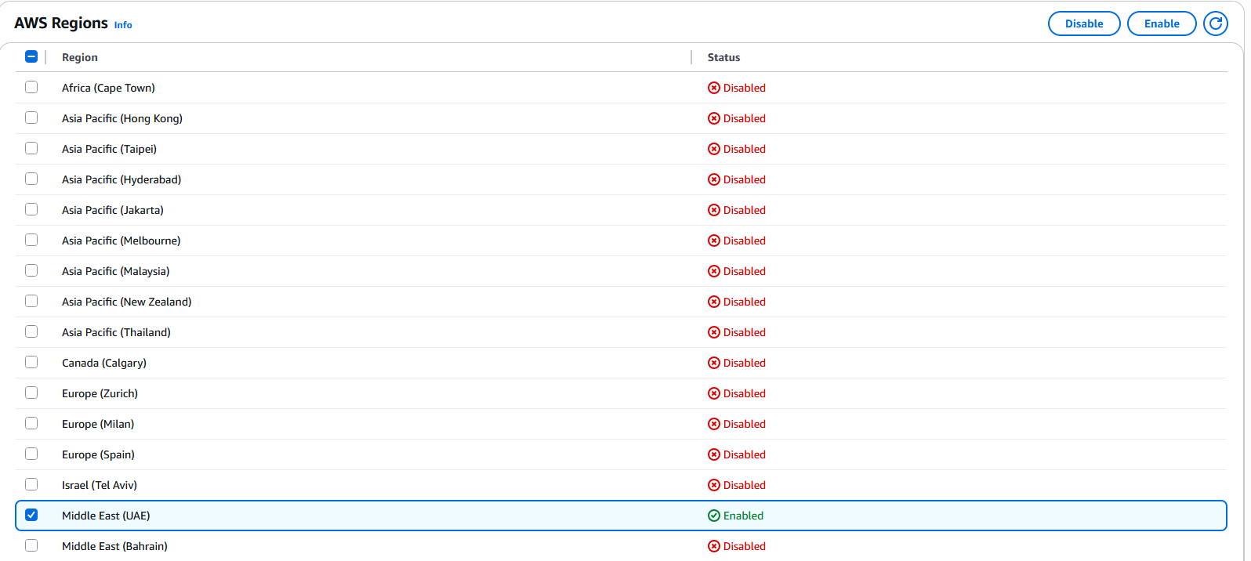

Task 2 — Create IAM Admin and Lab8User with console access
- Open IAM via Console search (Alt+S → "IAM").
Create the Admin user: IAM → Users → Create user. Fill:
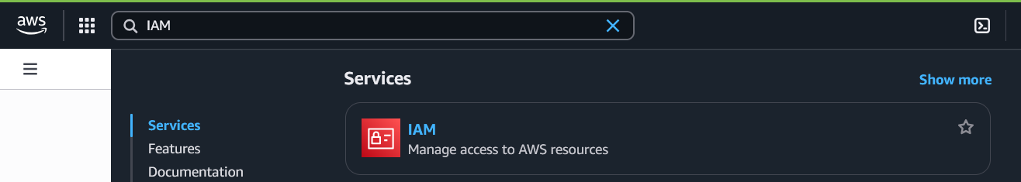

Create the Admin user: IAM → Users → Create user. Fill:
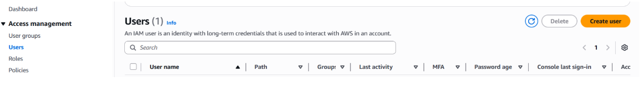
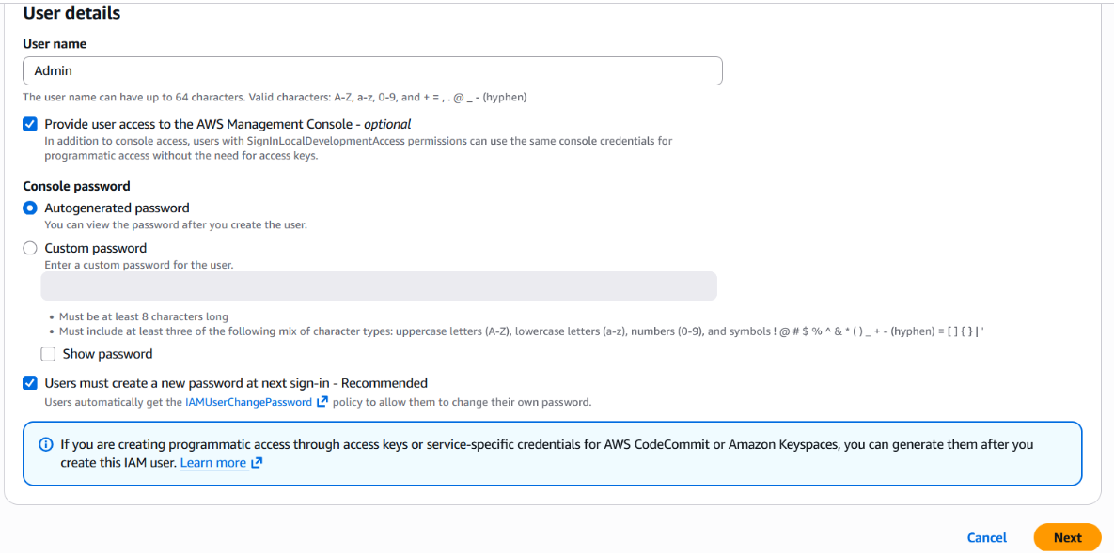
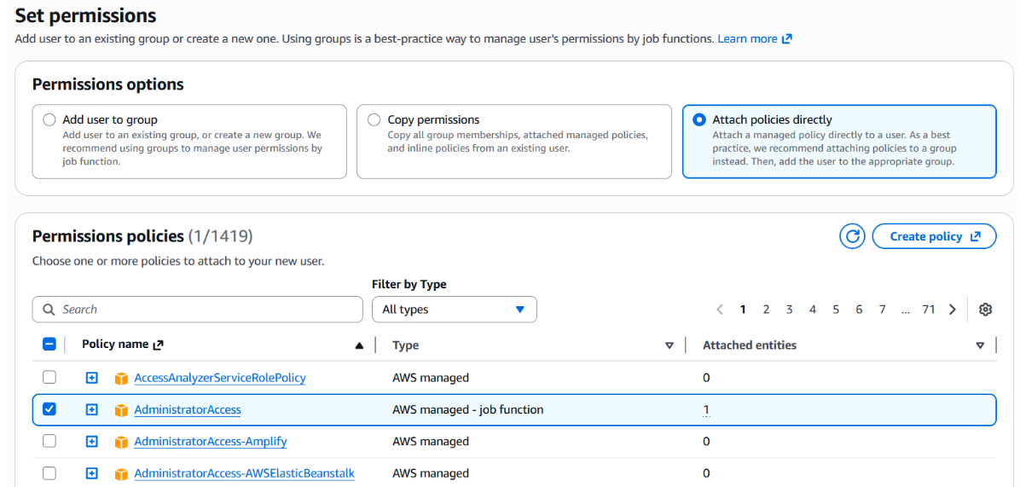

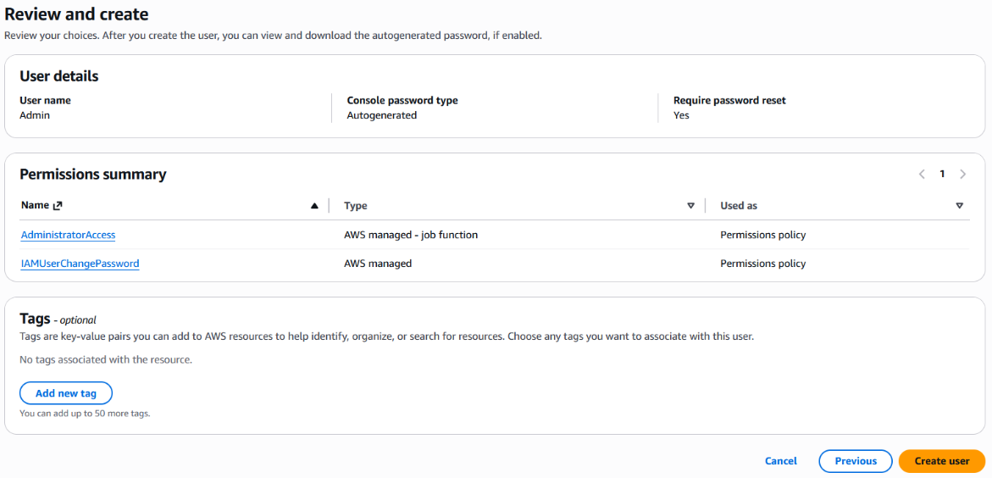

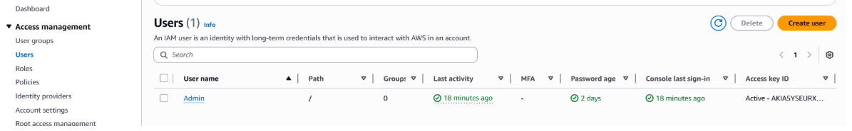

Download the Admin .csv and show its presence on your Windows host (do not display the password text):

While logged in as Admin, create Lab8User:
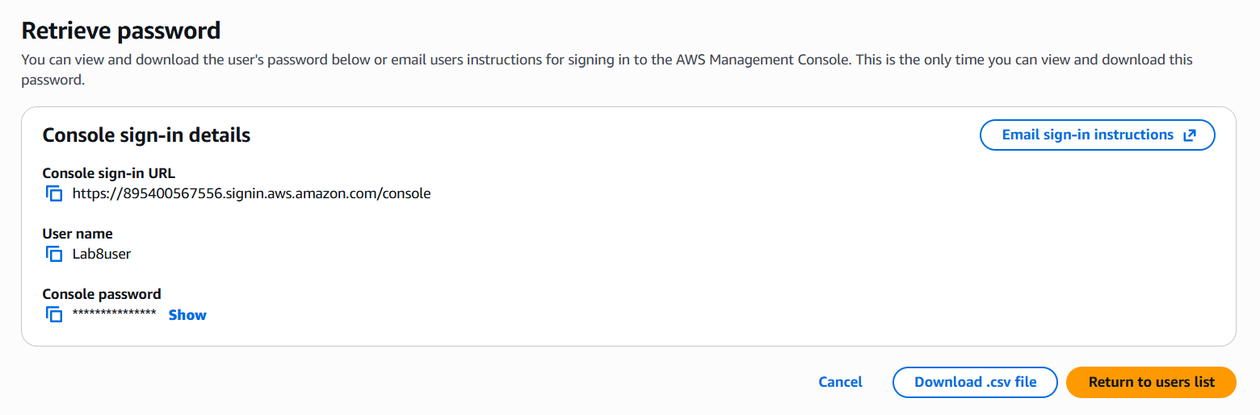
Download/save the Lab8User CSV on your Windows host (do not show password).

Logout Admin and login as Lab8User (use the Lab8User signin URL and credentials). Capture after login:
Task 2 summary (combine evidence):
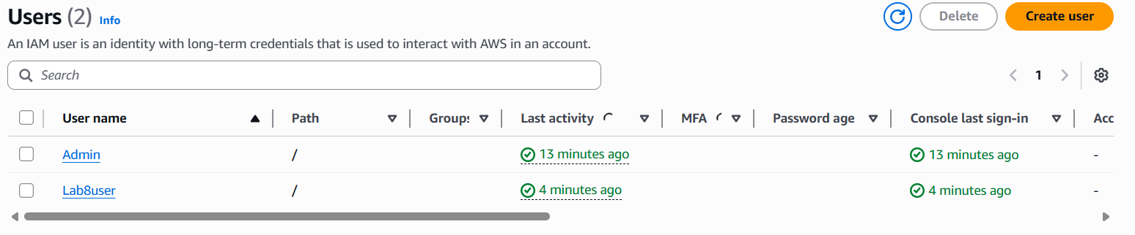

Task 3 — Inspect VPC resources (in UAE me-central-1)
Goal: In the VPC console list the counts of specific resources.
Do these steps in order and capture a screenshot immediately after viewing each page. Place screenshots in Lab8/screenshots/.

Steps and required screenshots:
- Open VPC console (Alt+S → "VPC") while region is me-central-1.
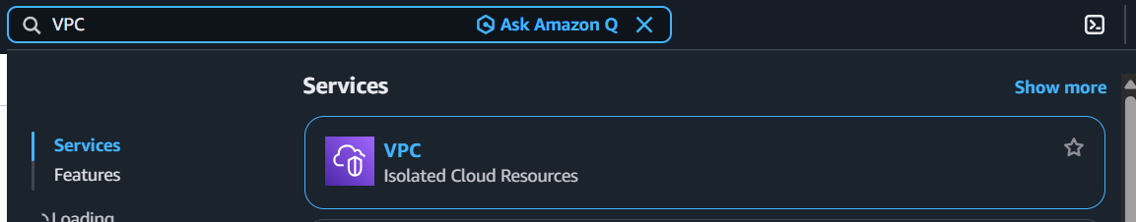
View VPCs list. Capture:
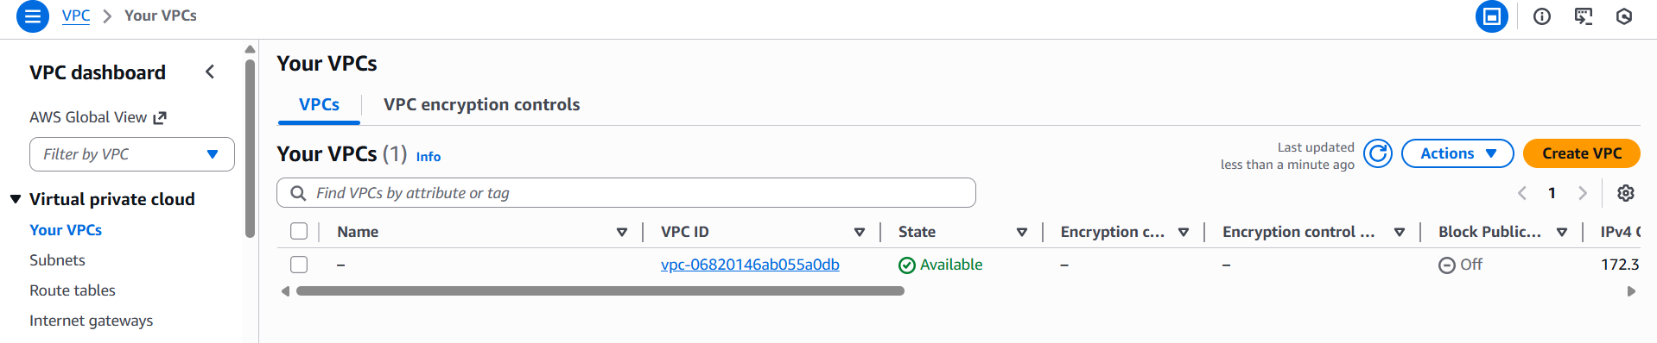

View Subnets list. Capture:
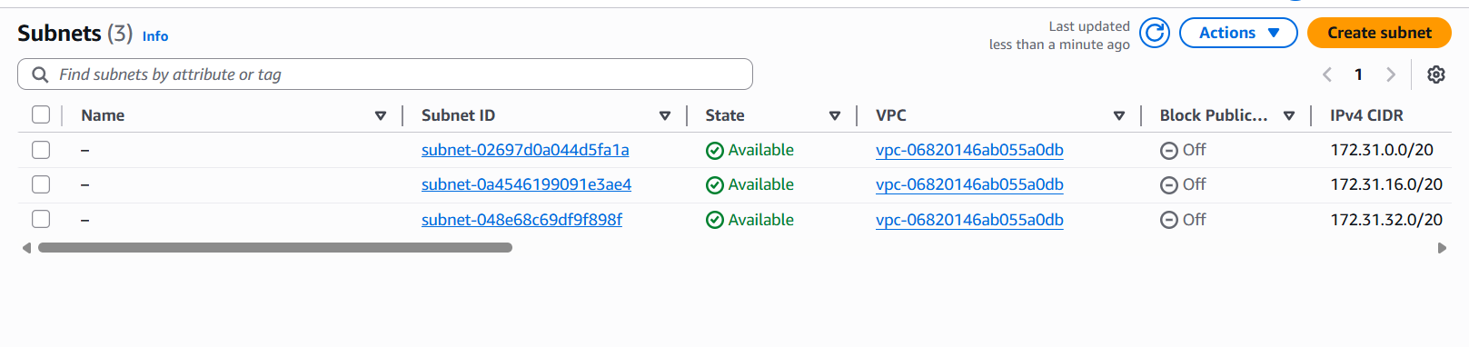

View Route Tables list. Capture:

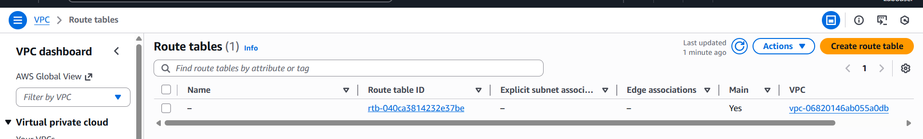

View Network ACLs list. Capture:
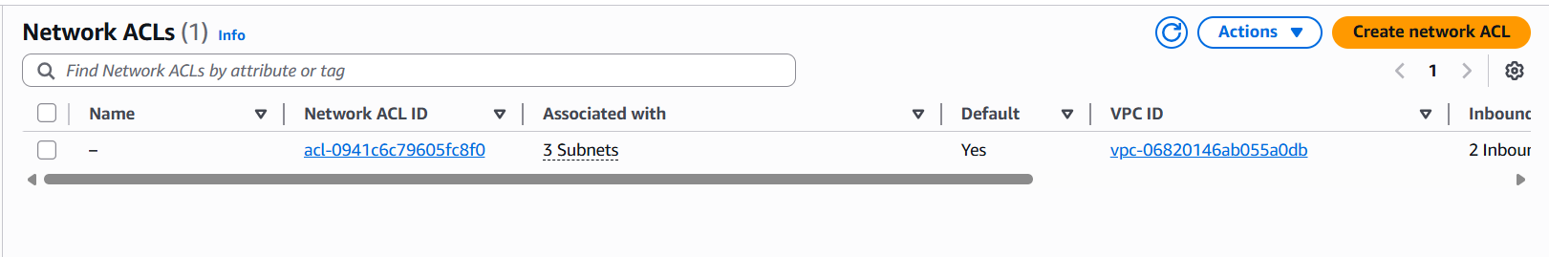

Task 3 summary (combine evidence):
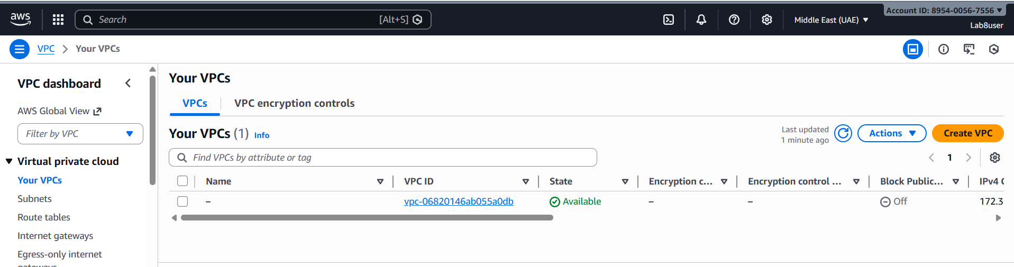

Task 4 — Launch EC2, SSH, install Docker & Docker Compose, deploy Gitea
Goal: Launch an EC2 instance named Lab8Machine, configure security group Lab8SecurityGroup allowing SSH from your IP, create an ED25519 key pair Lab8Key (.pem), SSH from Windows host, install Docker & Docker Compose, create compose.yaml from the repository, run docker compose up -d, allow inbound TCP port 3000, and open Gitea UI.

Steps and required screenshots:
- Open EC2 Console (Alt+S → "EC2") (me-central-1).
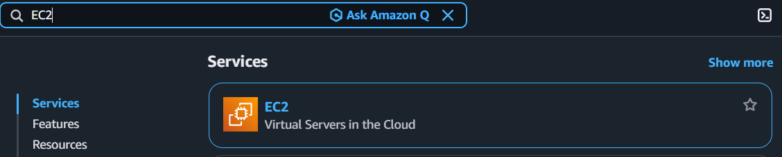
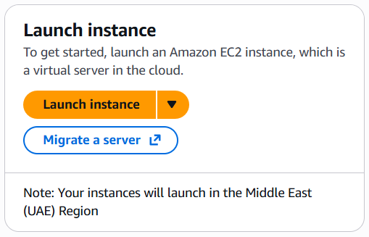

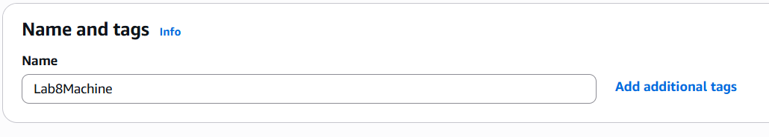

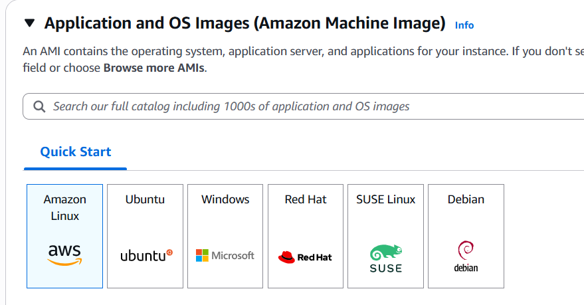

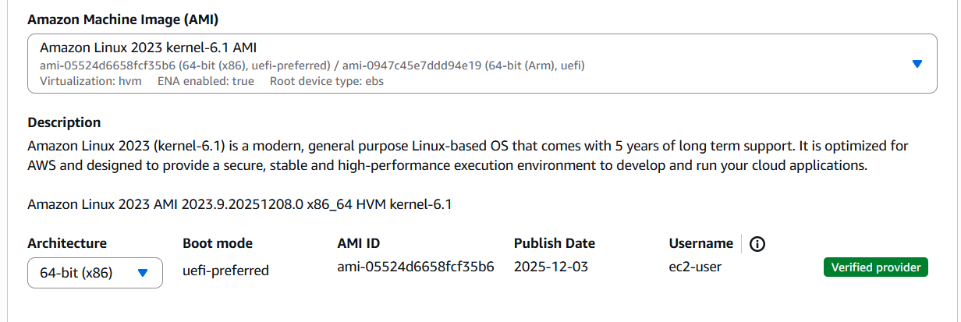

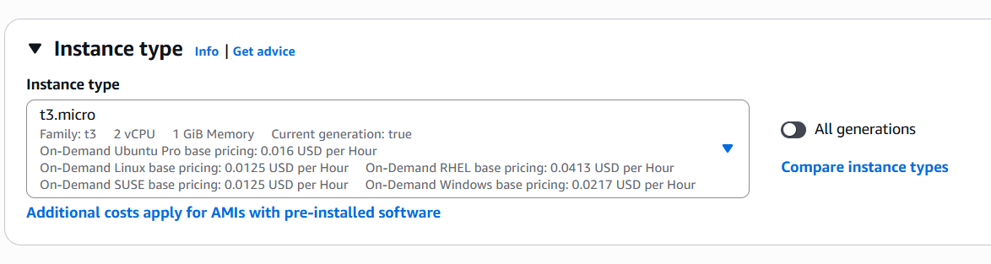

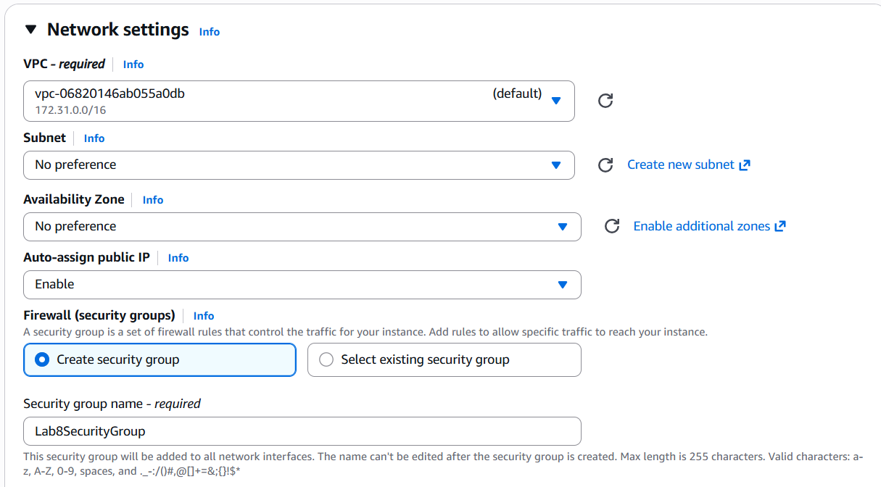

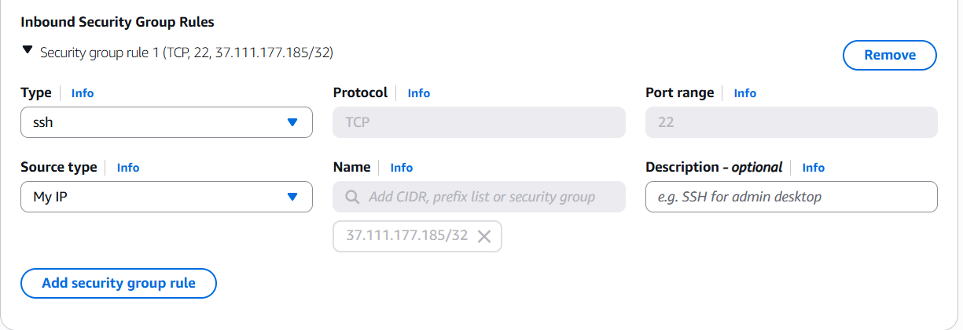

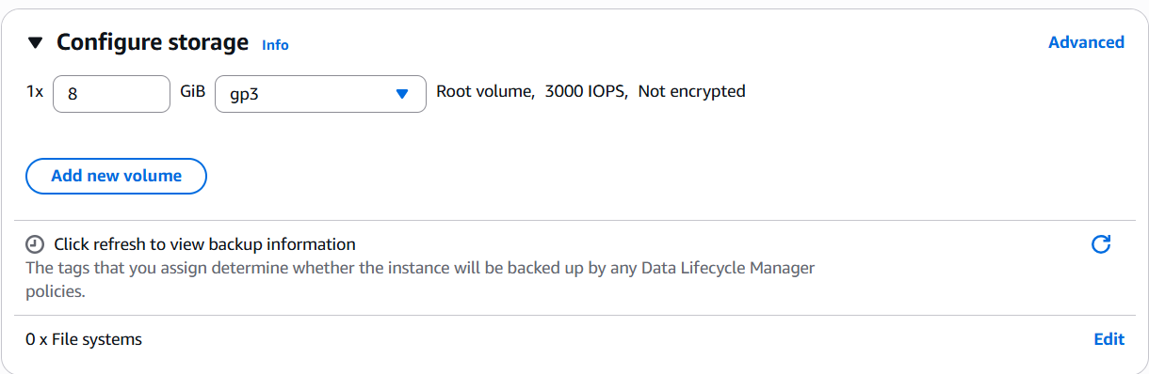
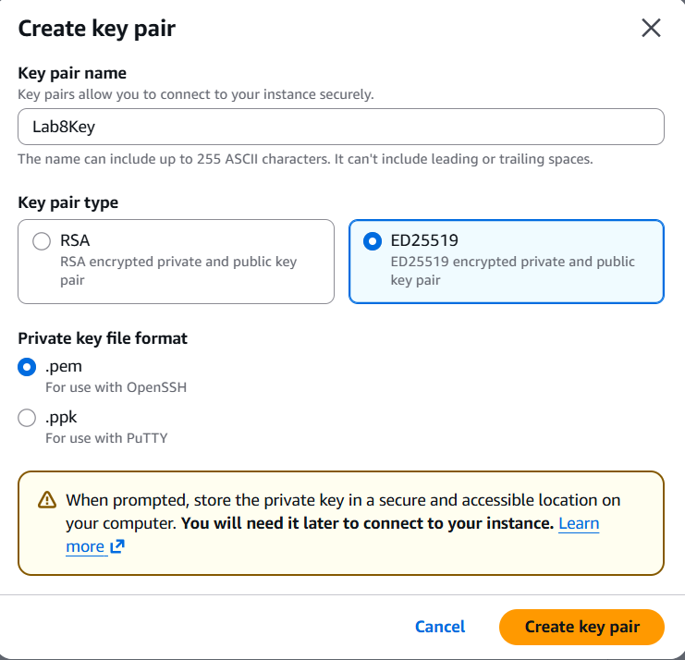

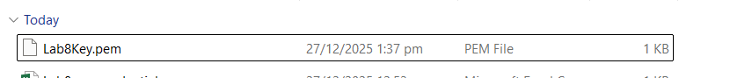

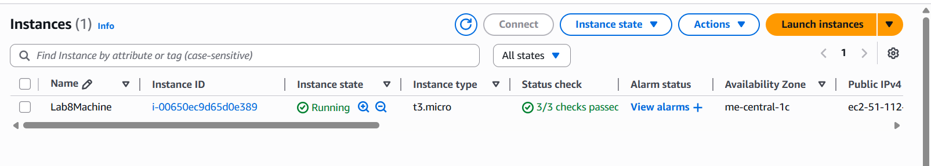
After launch, EC2 Instances list showing Lab8Machine in "running" state and public IPv4 visible.’
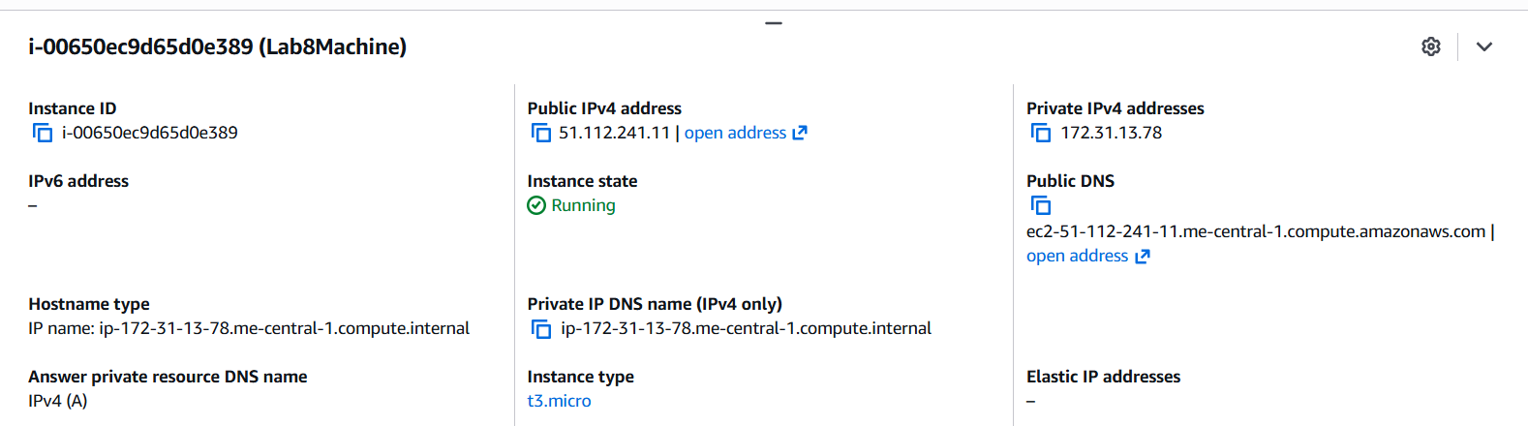
On Windows host, run SSH using the downloaded .pem (PowerShell/Git Bash/Windows Terminal):
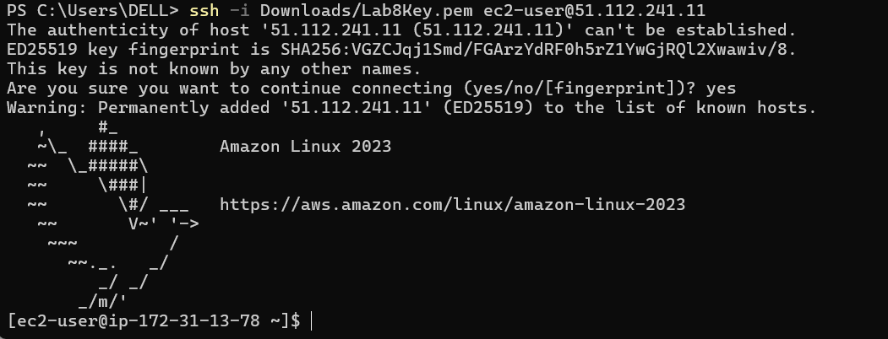
Run the install commands on the EC2 shell:

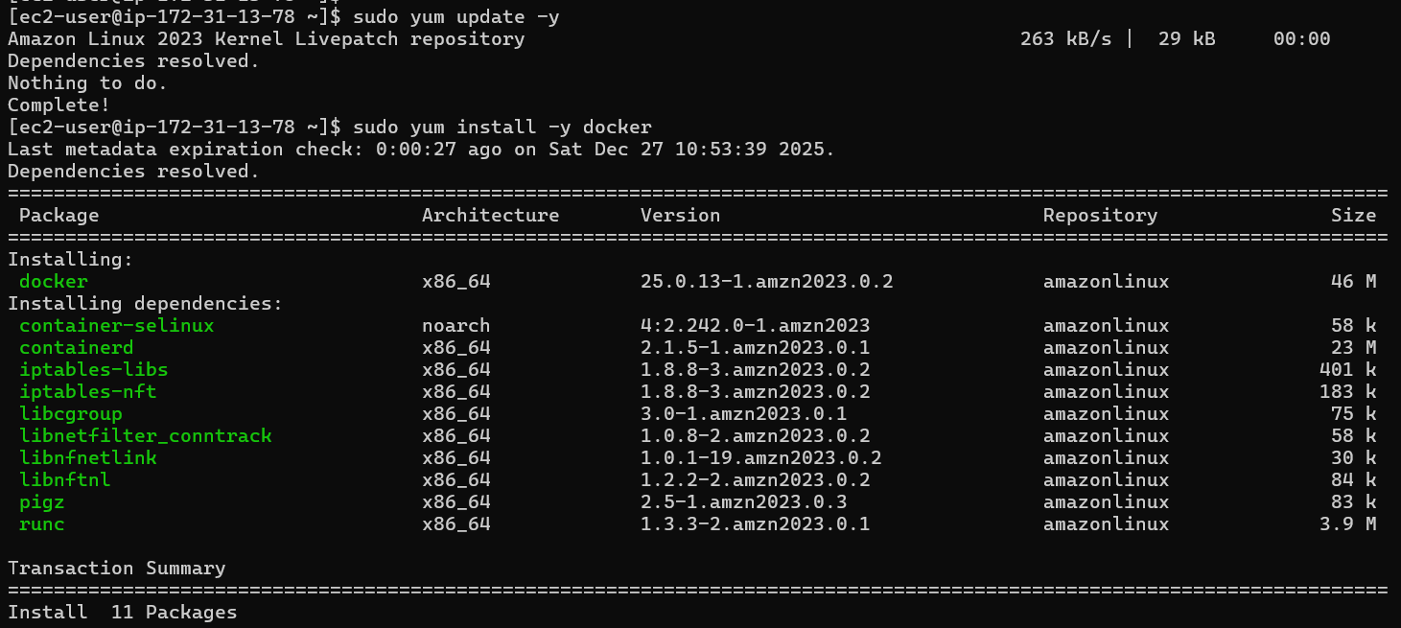
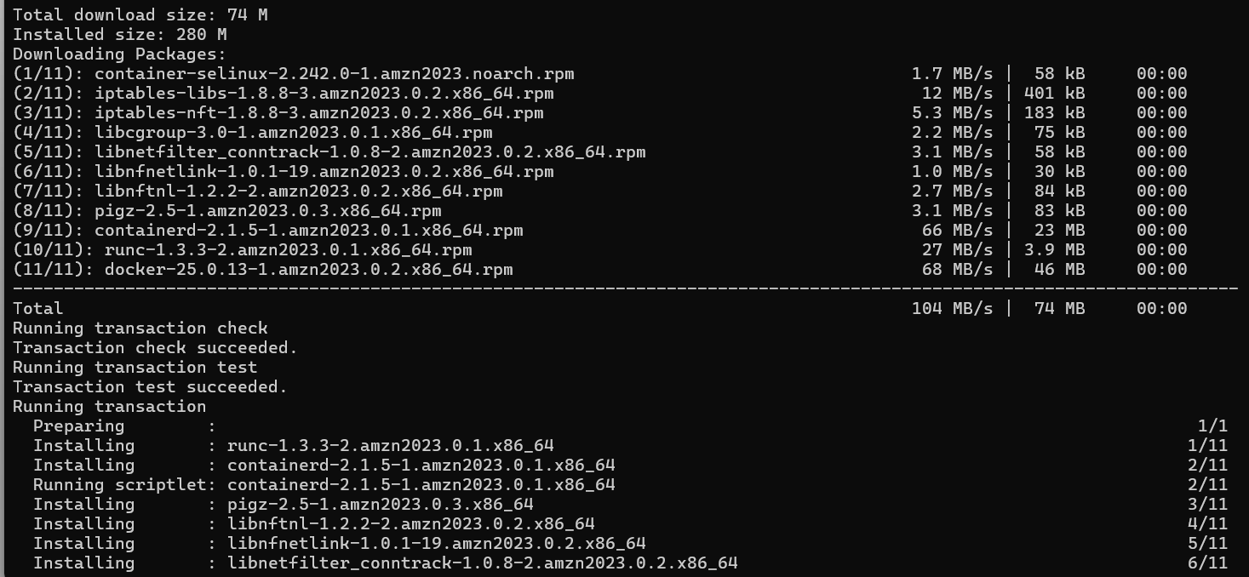

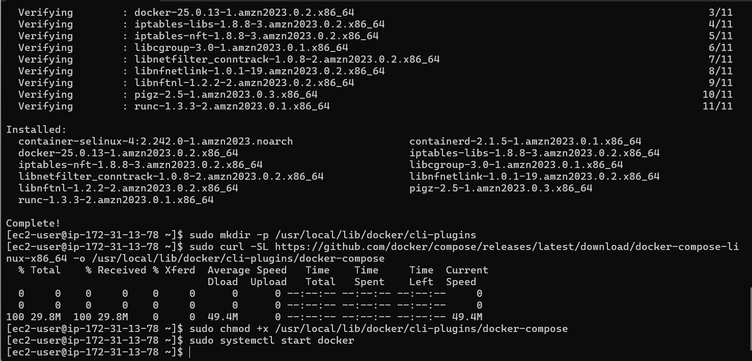
Create/edit compose.yaml on the EC2 instance (sudo vim compose.yaml) and paste content from the repo: Gitea . While pasting, capture the editor content:
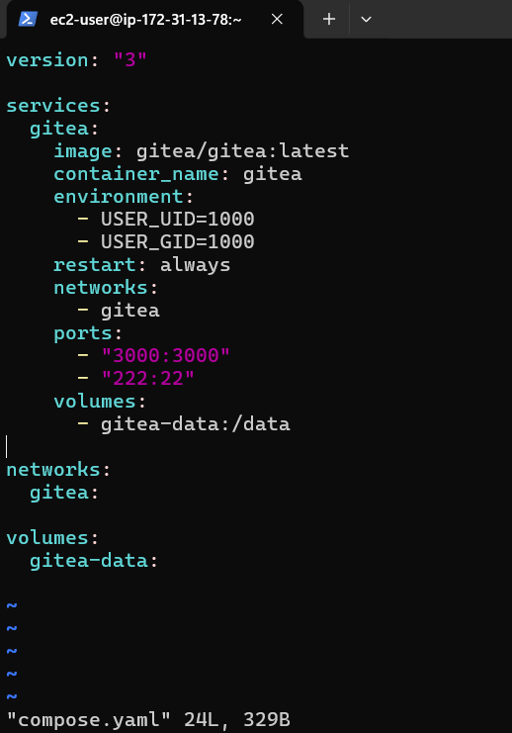

Save and verify file exists:
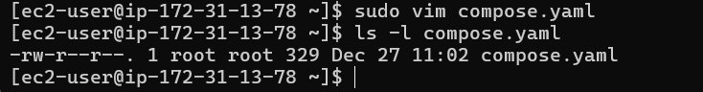
Add ec2-user to docker group, show groups before re-login, exit and reconnect, show groups after reconnect:
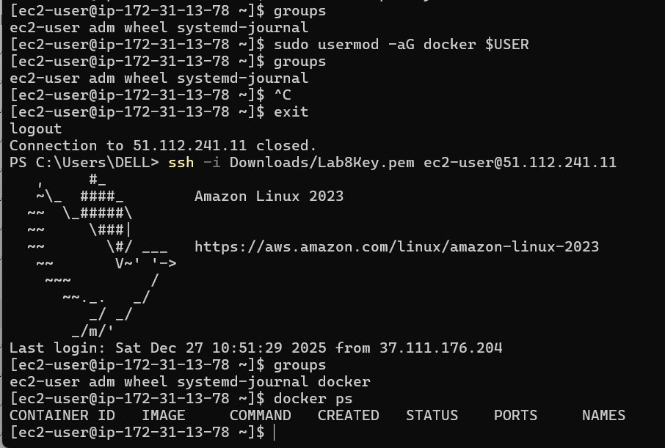
Run docker compose up -d from the directory with compose.yaml:
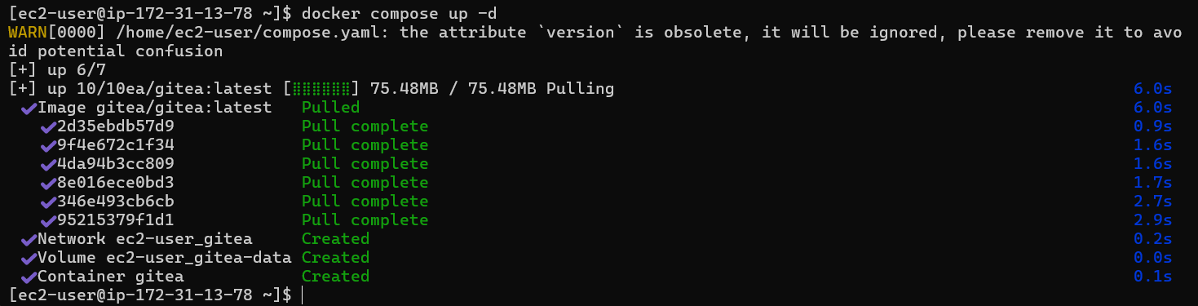

Edit the security group Lab8SecurityGroup inbound rules in the EC2 console: add Custom TCP rule port 3000 source 0.0.0.0/0 and save. Capture the inbound rules after saving:
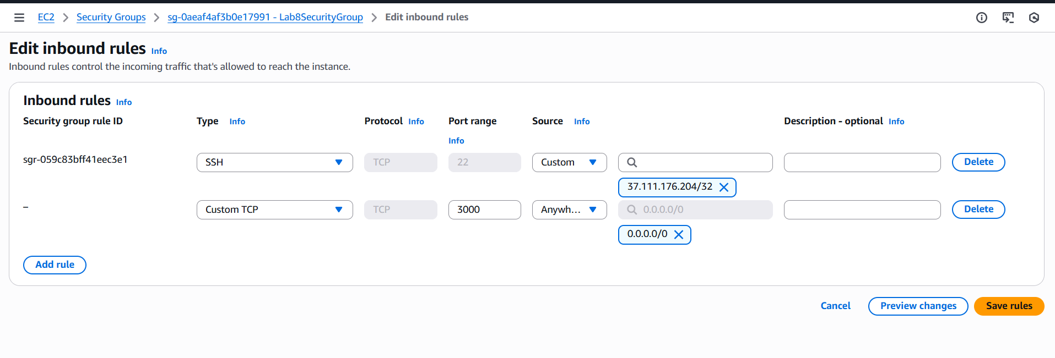

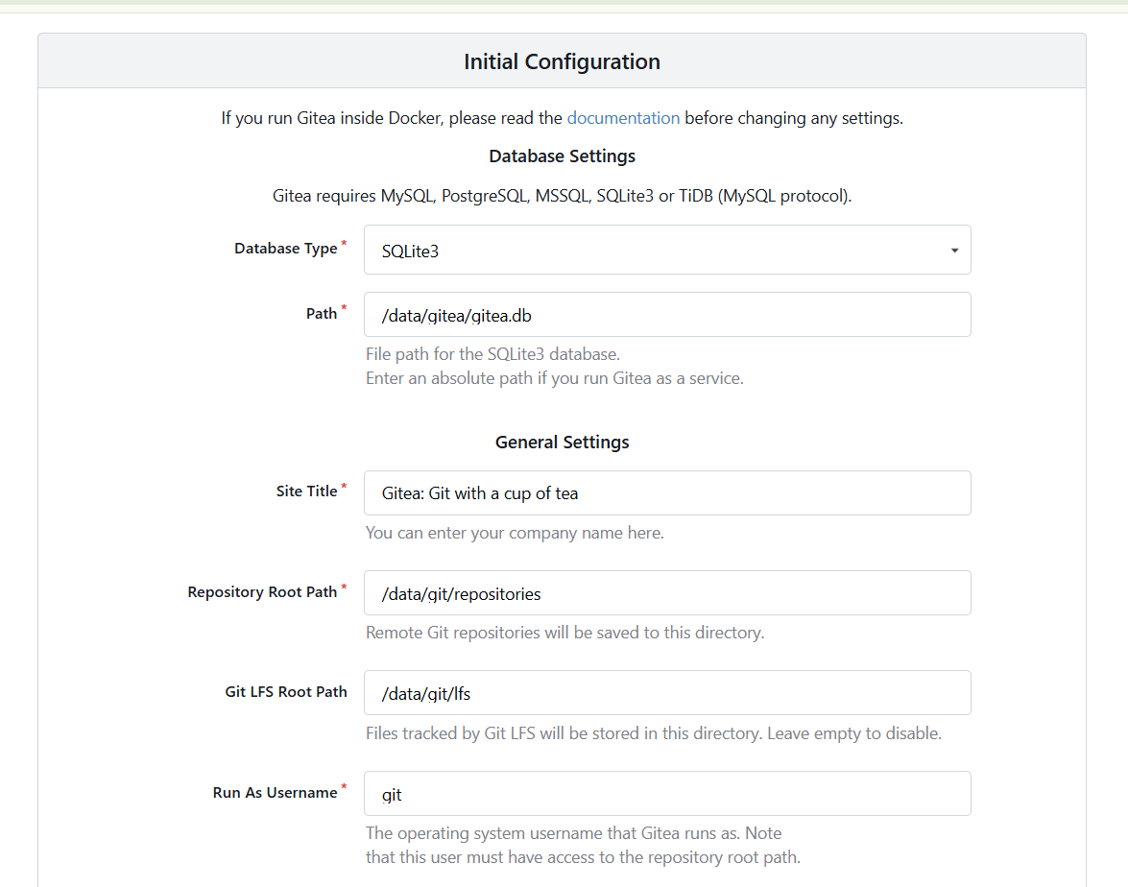

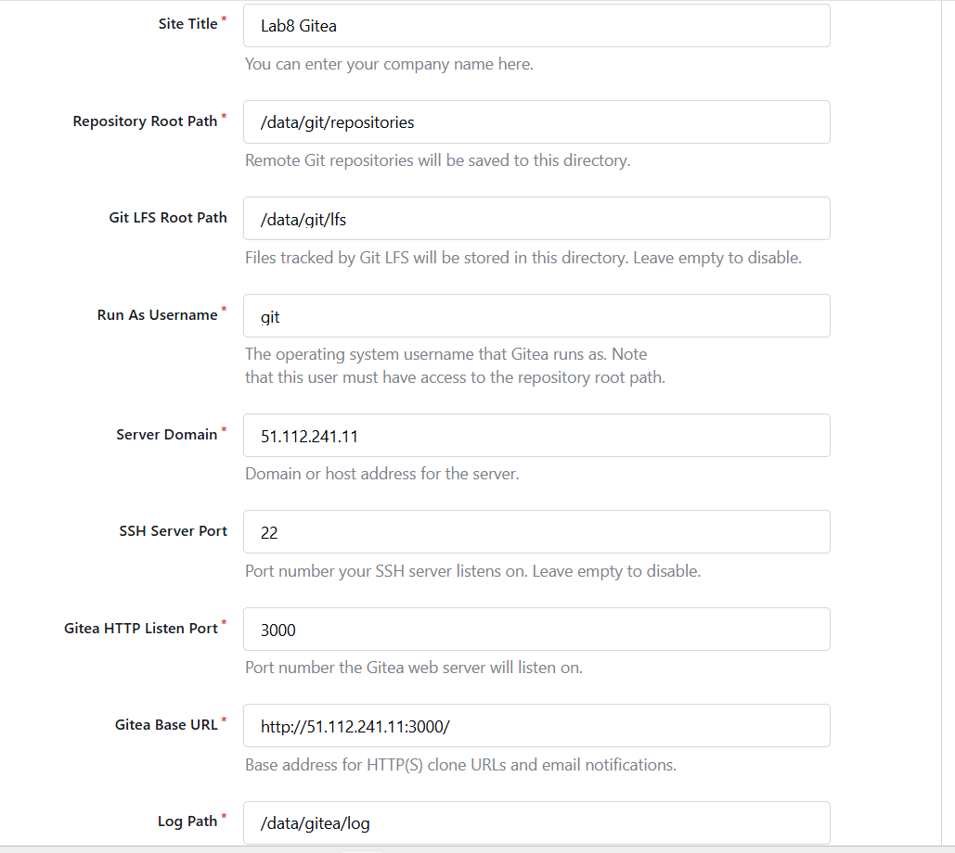
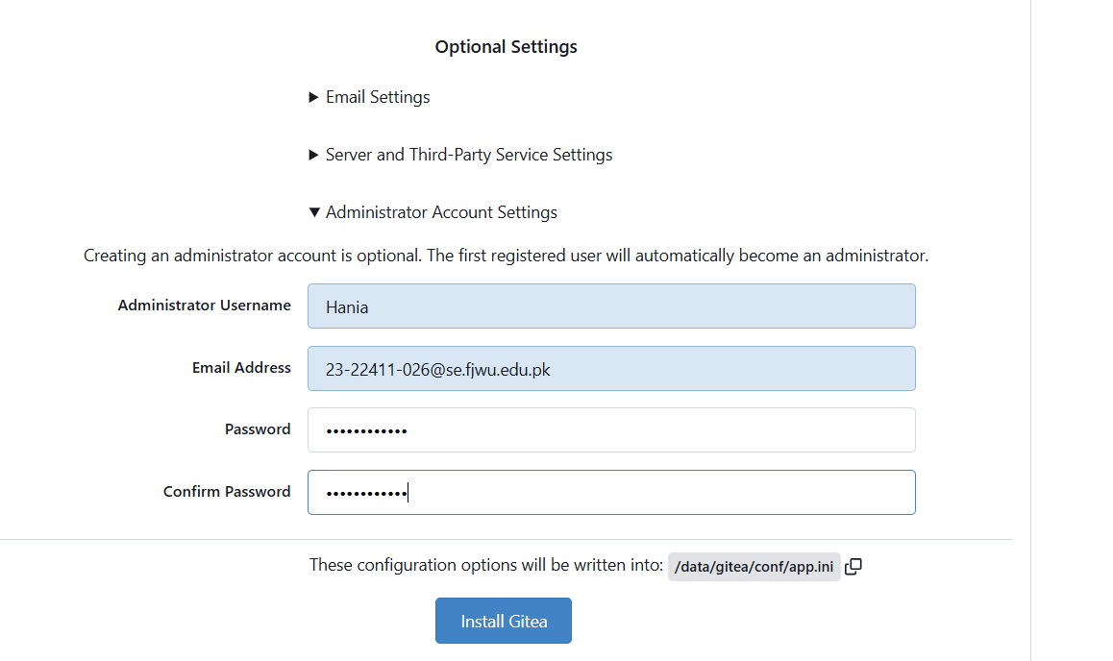

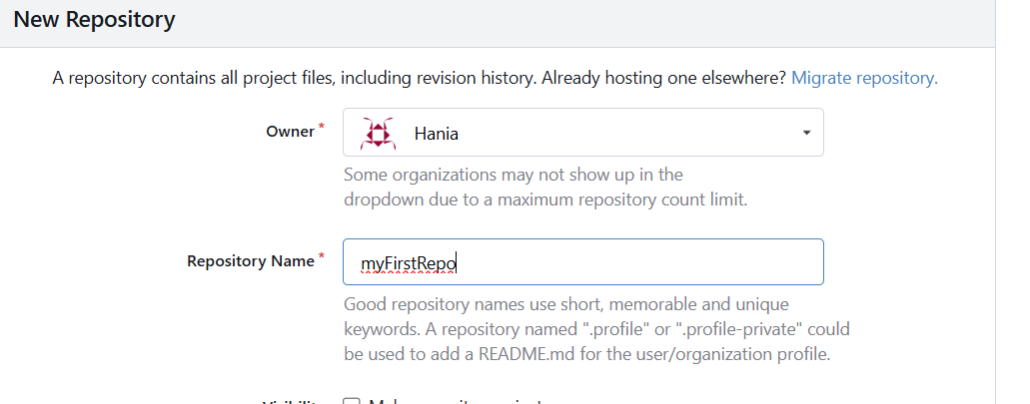

Cleanup — Remove resources to avoid charges
After verification, terminate and delete everything you created. Capture screenshots immediately after each cleanup step.
Cleanup steps and required screenshots:
- Terminate the EC2 instance Lab8Machine.

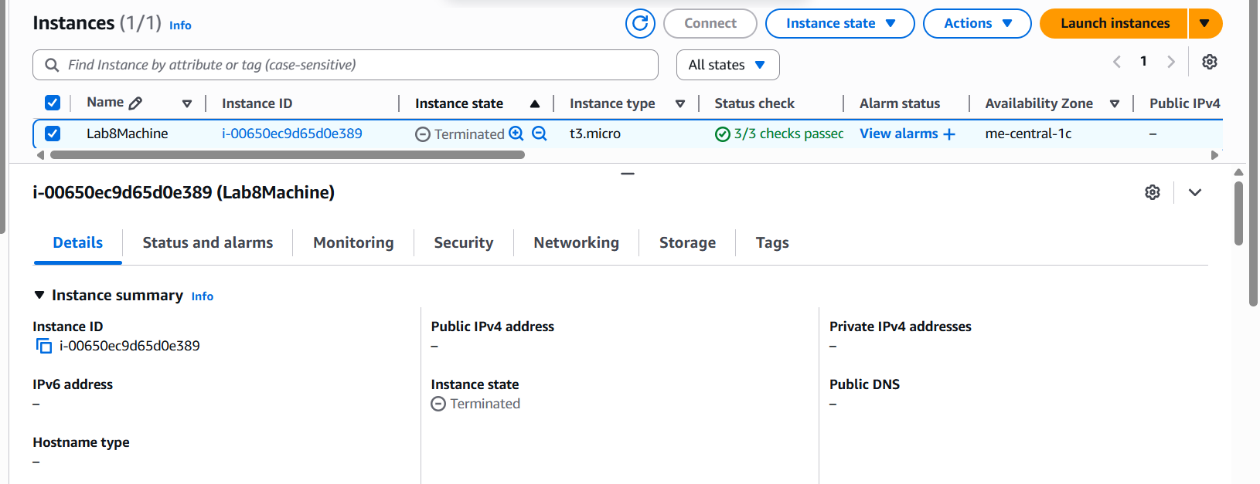

Delete security group Lab8SecurityGroup and key pair Lab8Key from the EC2 console (after instances terminated).
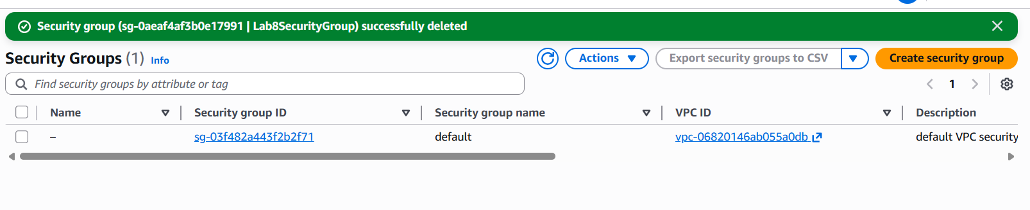

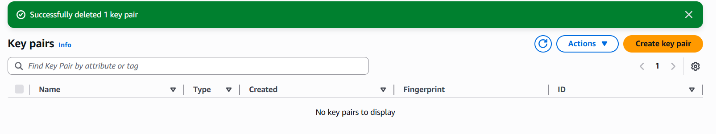

Delete IAM users Lab8User and any access keys.
